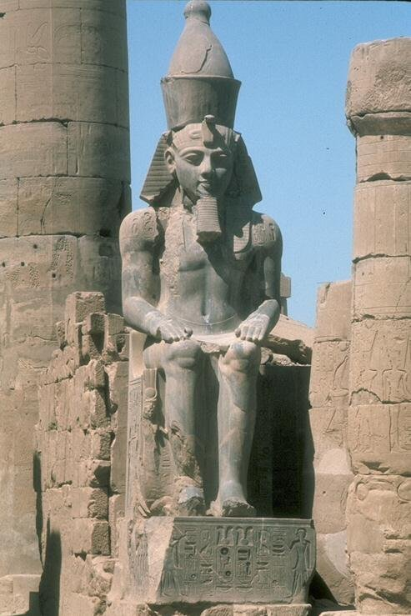


FACULTY OF COMPUTER
AND INFORMATION SCIENCE
ASSIUT UNIVERSITY
By Engineer
Ahmed Gamal

Report about the lecture of Dr/Nadia Elkhateb

Supervised By:
Dr. Taysir Hassan Abdel Hamid

Group members:
1- Ahmed Mohamed Gamal El_Deen.
2- Ahmed khalaf Ahmed Abdel Rahem.
3 -Tarek Mohamed Mohamed.
4-Abdelrady Elagamy Abdelrady.
5-Mostafa Hassan Mohamed.

Third Year

May-07

